BRACT’s
Vishwakarma Institute of Technology, Pune
Practical Implementation Sheet
Department: CSE-AI Semester: 5 Academic Year: 2026-27
Division: E Batch: 3 Practical No: 3
Roll no: 68 PRN No: 12412100 Name of Student: Shreyas Shinde
Subject Name : Deep Learning

Problem Statement : Design and implement a Multilayer Perceptron (MLP) for classification of the Iris or Wine dataset, and evaluate its performance using accuracy and a confusion matrix.

Algorithm :
- Import the required libraries.
- Load the Iris dataset from the Scikit-learn library.
- Separate the dataset into input features (X) and target labels (y).
- Split the dataset into training and testing sets using an 80:20 ratio.
- Standardize the feature values using StandardScaler.
- Create a Multilayer Perceptron (MLP) classifier with two hidden layers.
- Train the MLP model using the training dataset.
- Predict the class labels for the testing dataset.
- Calculate the classification accuracy.
- Generate the confusion matrix and classification report.
- Visualize:
  - Class distribution of the dataset
  - Training loss curve
  - Confusion matrix
- Display the model accuracy and performance metrics.

Code :

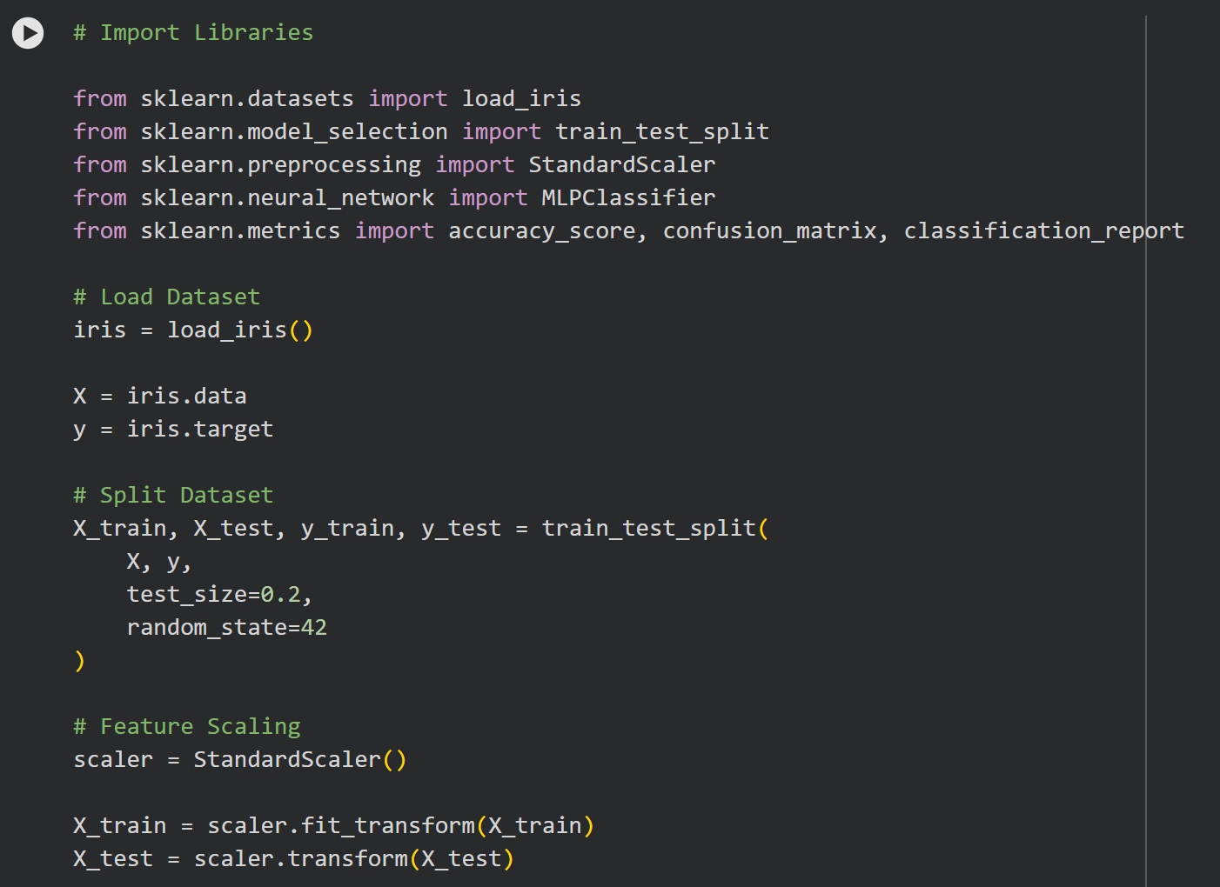
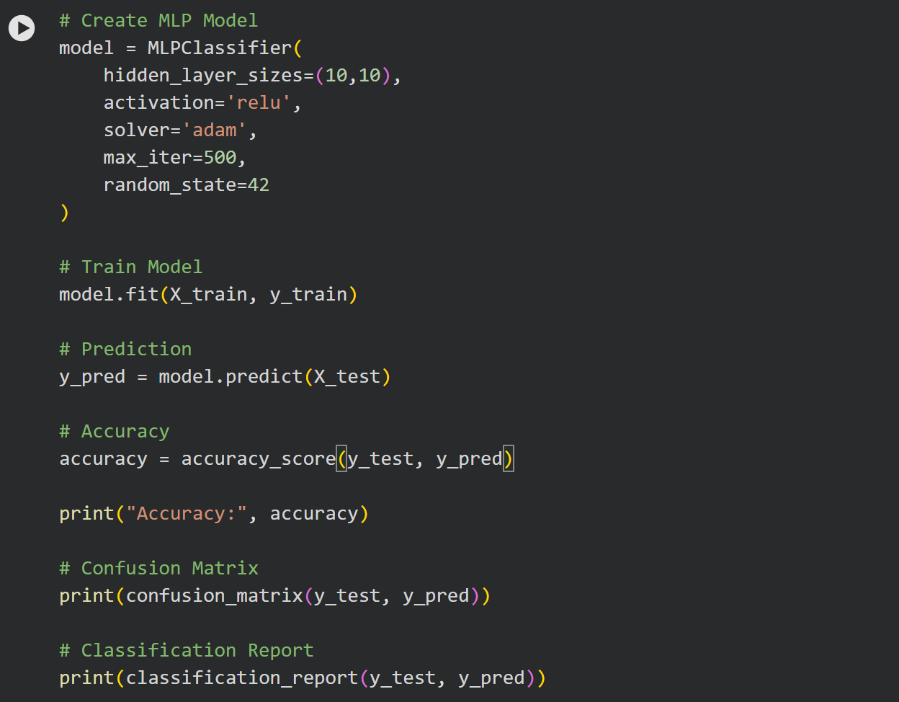

Output :
